Glaucoma Detection from Retinal Fundus Images using a Multi-Layer Perceptron (MLP) Neural Network
(Glaucoma Image Classification using Neural Network)
Problem Statement:
Glaucoma is one of the leading causes of irreversible blindness worldwide, caused by progressive damage to the optic nerve. It is often called the “silent thief of sight” because noticeable vision loss occurs only after significant, irreversible damage has already taken place. Manual screening of retinal fundus images by an ophthalmologist is accurate but time-consuming, subjective, and not easily scalable to large at-risk populations, particularly in areas with limited access to eye-care specialists.
There is, therefore, a need for an automated, fast, and accessible system that can analyze a retinal fundus image and classify it as Normal or Glaucomatous with a measurable confidence score, so that suspected cases can be flagged early for a specialist's review. This project designs and implements a web-based Glaucoma Image Classification system that performs image preprocessing, handcrafted feature extraction, and classification using a Multi-Layer Perceptron (MLP) neural network, and evaluates the trained model using standard classification metrics (Accuracy, Precision, Recall, F1-Score, Confusion Matrix).
Objectives:
- To collect and preprocess a labelled dataset of Normal and Glaucomatous retinal fundus images.
- To extract meaningful handcrafted features (colour histograms, spatial gradients, Sobel edge energy) from each image.
- To design, train, and save a Multi-Layer Perceptron (MLP) neural network classifier using the extracted features.
- To build a Flask-based backend and web front-end that lets a user upload a fundus image and view the diagnosis.
- To evaluate the trained model on an unseen test set and report Accuracy, Precision, Recall, F1-score and the Confusion Matrix.
- To persist every prediction (filename, class, confidence, timestamp) in an SQLite database for record-keeping.
Software / Hardware Required:
• Operating System: Windows / Linux / macOS
• IDE: Visual Studio Code
• Language: Python 3.x
• Backend Framework: Flask (REST API)
• Machine Learning: scikit-learn (MLPClassifier)
• Image Processing: OpenCV (cv2), Pillow (PIL), NumPy
• Database: SQLite3
• Frontend: HTML5, CSS3, JavaScript
• Dataset: Kaggle Glaucoma Fundus Image dataset (Normal / Glaucoma classes)
• Version Control: Git

Project Directory Structure:
The project (“GlaucomaClassifier”) is organized as a Flask backend with a separate dataset, trained-model, and frontend folder, as shown below.
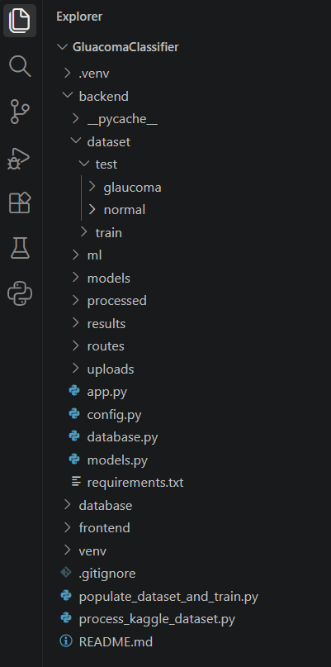
Fig 1: Project directory structure of GlaucomaClassifier in Visual Studio Code

Procedure:
1. Collect a labelled fundus-image dataset (Normal / Glaucoma) and organize it into backend/dataset/train and backend/dataset/test folders.
2. Run process_kaggle_dataset.py to clean, split and organize the raw Kaggle dataset into the project's dataset structure.
3. Launch the Flask application (app.py) and open the web front-end in the browser.
4. Load / upload a fundus image through the interface (Step 1).
5. Preprocess the image — resize to 224×224, convert to RGB, apply Gaussian denoising and CLAHE contrast enhancement, and normalize pixel values to [0, 1] (Step 2).
6. Extract a 128-dimensional handcrafted feature vector from the preprocessed image using colour histograms, spatial gradients and Sobel edge energy (Step 3).
7. Train the Multi-Layer Perceptron (MLP) classifier on the extracted features (populate_dataset_and_train.py) using the Adam optimizer with L2 regularization for 15 epochs, and save the trained model to backend/models/glaucoma_model.pkl (Step 4).
8. Feed the extracted feature vector of the uploaded image to the trained model to obtain the predicted class (Normal / Glaucoma) with a confidence percentage (Step 5).
9. Evaluate the trained model on the held-out test set and compute Accuracy, Precision, Recall, F1-score and the Confusion Matrix (Step 6).
10. Log every prediction (filename, predicted class, confidence, timestamp) into the SQLite database (database/glaucoma.db) and display the prediction history (Step 7).

Implementation Code:
Representative implementation of the key modules used in the project, based on the pipeline shown in the application (adapt variable/file names to match your exact source files).
1. Image Preprocessing (ml/preprocessing.py)
import cv2
import numpy as np

def preprocess_image(image_path, target_size=(224, 224)):
img = cv2.imread(image_path)
img = cv2.cvtColor(img, cv2.COLOR_BGR2RGB) # RGB conversion
img = cv2.resize(img, target_size) # Resize to 224x224
img = cv2.GaussianBlur(img, (3, 3), 0) # Noise reduction

lab = cv2.cvtColor(img, cv2.COLOR_RGB2LAB)
l, a, b = cv2.split(lab)
clahe = cv2.createCLAHE(clipLimit=2.0, tileGridSize=(8, 8))
l = clahe.apply(l) # CLAHE contrast enhancement
img = cv2.cvtColor(cv2.merge((l, a, b)), cv2.COLOR_LAB2RGB)

img = img.astype(np.float32) / 255.0 # Normalize to [0, 1]
return img
2. Feature Extraction (ml/feature_extraction.py)
import cv2
import numpy as np

def extract_features(img):
# Colour histogram (per channel)
hist_feats = []
for ch in range(3):
hist = cv2.calcHist([img], [ch], None, [32], [0, 1])
hist_feats.extend(cv2.normalize(hist, hist).flatten())

# Spatial gradients
gray = cv2.cvtColor((img*255).astype('uint8'), cv2.COLOR_RGB2GRAY)
gx = cv2.Sobel(gray, cv2.CV_64F, 1, 0, ksize=3)
gy = cv2.Sobel(gray, cv2.CV_64F, 0, 1, ksize=3)
edge_energy = np.sqrt(gx**2 + gy**2)
grad_feats = [edge_energy.mean(), edge_energy.std()]

features = np.array(hist_feats + grad_feats, dtype=np.float32)
return features[:128] # 128-dimensional feature vector
3. Model Training (populate_dataset_and_train.py)
from sklearn.neural_network import MLPClassifier
from sklearn.model_selection import train_test_split
import joblib, numpy as np

X = np.load('processed/features.npy') # (n_samples, 128)
y = np.load('processed/labels.npy') # 0 = Normal, 1 = Glaucoma

X_train, X_val, y_train, y_val = train_test_split(
X, y, test_size=0.2, stratify=y, random_state=42)

model = MLPClassifier(
hidden_layer_sizes=(64, 32),
activation='relu',
solver='adam',
alpha=0.001, # L2 regularization
max_iter=15,
random_state=42)

model.fit(X_train, y_train)
print('Validation accuracy:', model.score(X_val, y_val))

joblib.dump(model, 'backend/models/glaucoma_model.pkl')
4. Prediction Route (backend/routes/predict.py)
from flask import Blueprint, request, jsonify
import joblib
from ml.preprocessing import preprocess_image
from ml.feature_extraction import extract_features

predict_bp = Blueprint('predict', __name__)
model = joblib.load('backend/models/glaucoma_model.pkl')
CLASSES = ['Normal', 'Glaucoma']

@predict_bp.route('/predict', methods=['POST'])
def predict():
file = request.files['image']
path = f'backend/uploads/{file.filename}'
file.save(path)

img = preprocess_image(path)
features = extract_features(img).reshape(1, -1)

proba = model.predict_proba(features)[0]
pred_idx = proba.argmax()

result = {
'prediction': CLASSES[pred_idx],
'confidence': round(float(proba[pred_idx]) * 100, 1),
'glaucoma_prob': round(float(proba[1]) * 100, 1),
'normal_prob': round(float(proba[0]) * 100, 1)
}
return jsonify(result)
5. Saving Prediction History (database.py)
import sqlite3, datetime

def log_prediction(filename, prediction, confidence):
conn = sqlite3.connect('database/glaucoma.db')
cur = conn.cursor()
cur.execute('''CREATE TABLE IF NOT EXISTS history (
id INTEGER PRIMARY KEY AUTOINCREMENT,
filename TEXT, prediction TEXT,
confidence REAL, created_at TEXT)''')
cur.execute('INSERT INTO history (filename, prediction, confidence, created_at) VALUES (?, ?, ?, ?)',
(filename, prediction, confidence, datetime.datetime.now().isoformat()))
conn.commit()
conn.close()
Output (Step-by-Step Screenshots):
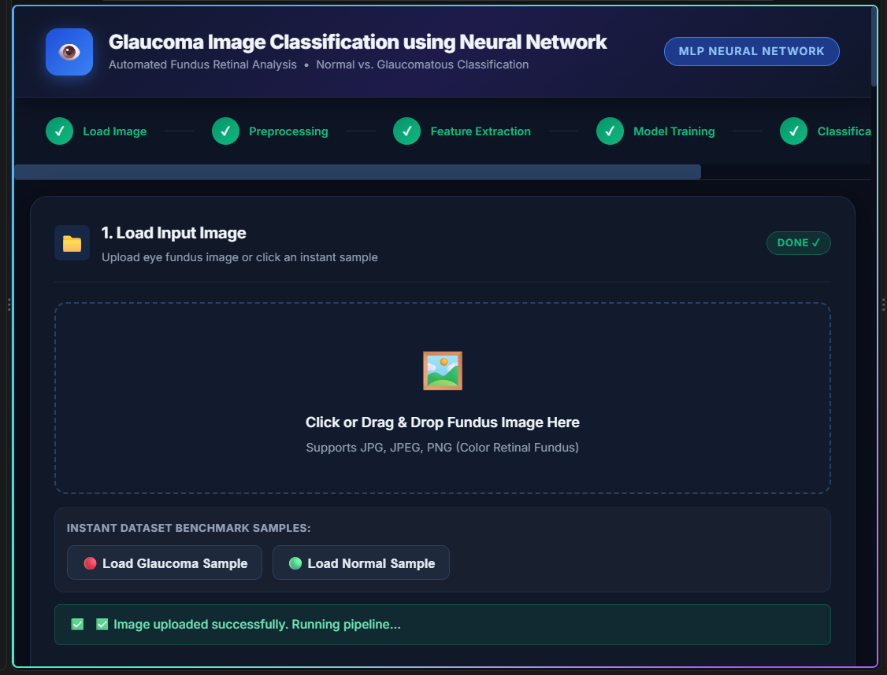
Fig 2: Step 1 — Load Input Image: interface to upload a fundus image or load a benchmark sample
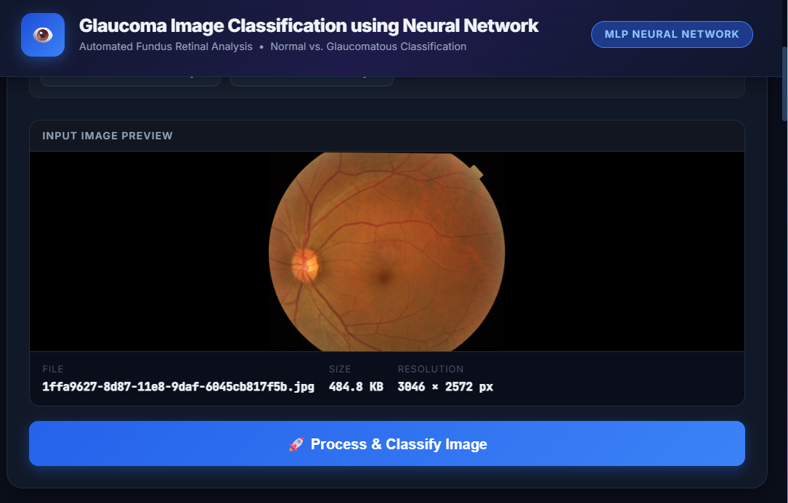
Fig 3: Step 1 — Input image preview after a fundus image is uploaded

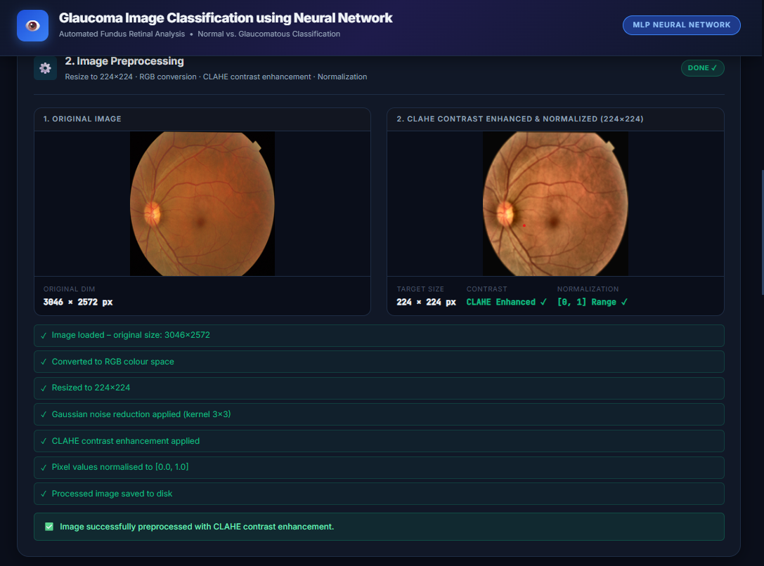
Fig 4: Step 2 — Image preprocessing: original image vs. CLAHE contrast-enhanced & normalized (224×224) image
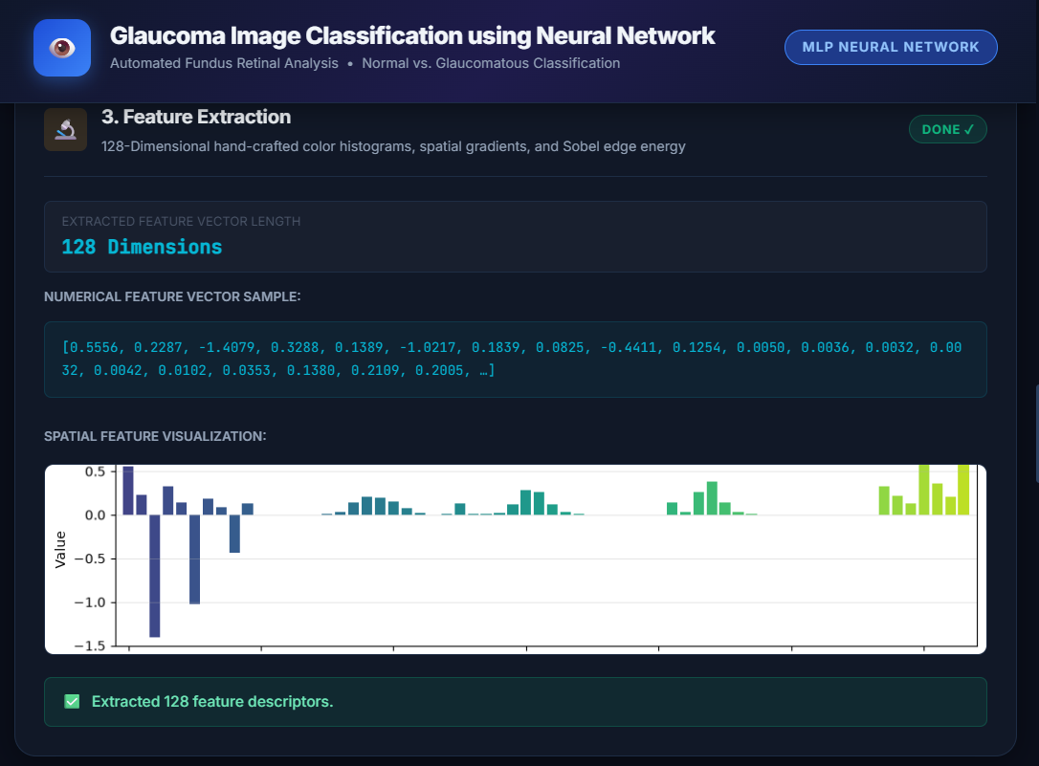
Fig 5: Step 3 — Feature extraction: 128-dimensional feature vector and spatial feature visualization (Sample 1)

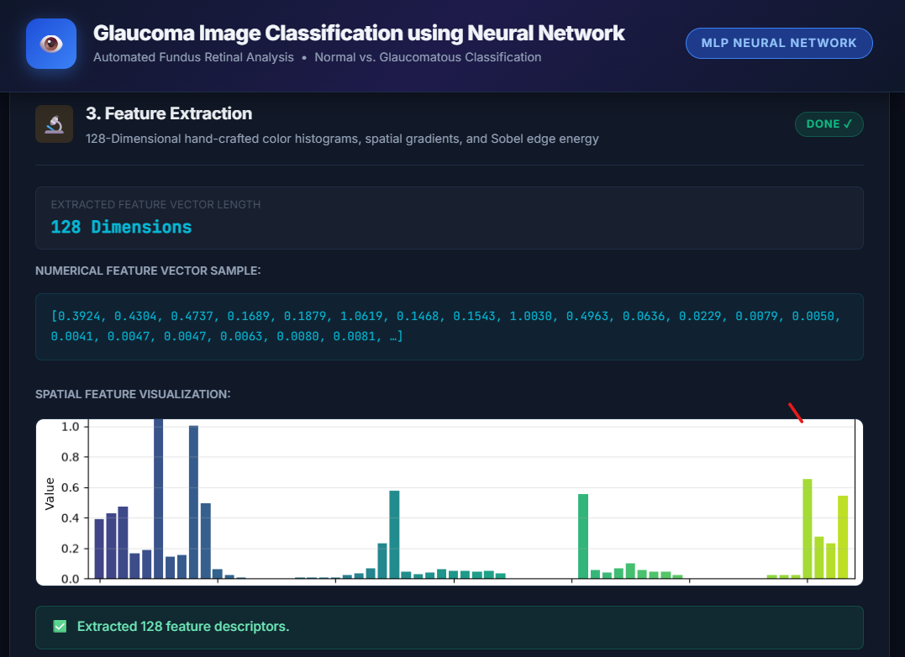
Fig 6: Step 3 — Feature extraction: 128-dimensional feature vector and spatial feature visualization (Sample 2)
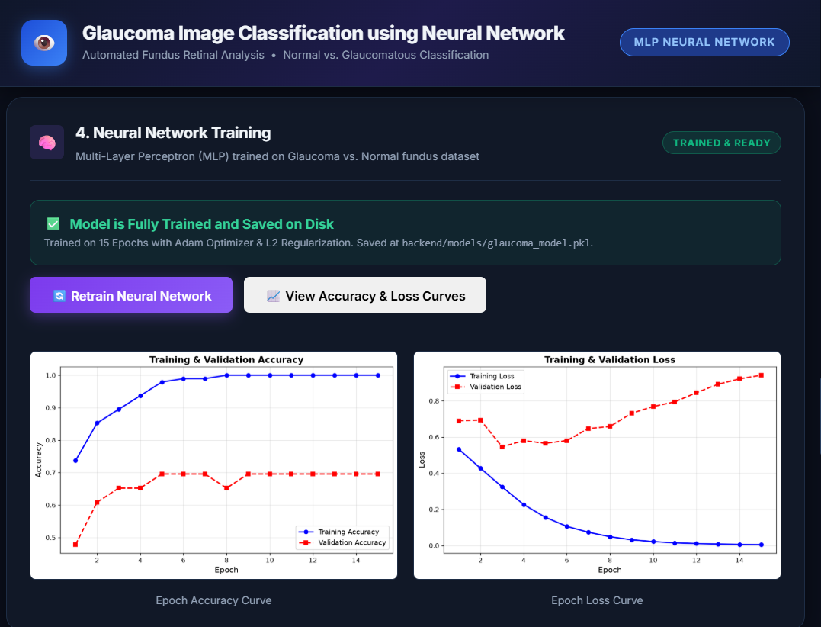
Fig 7: Step 4 — Neural network training completed: training & validation accuracy and loss curves
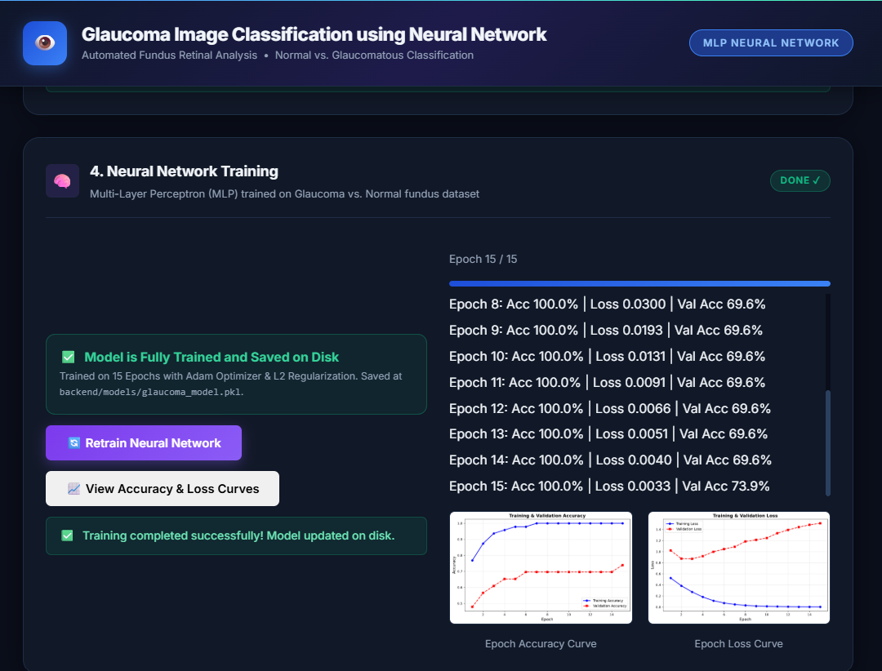
Fig 8: Step 4 — Epoch-by-epoch training log (Adam optimizer, L2 regularization, 15 epochs)
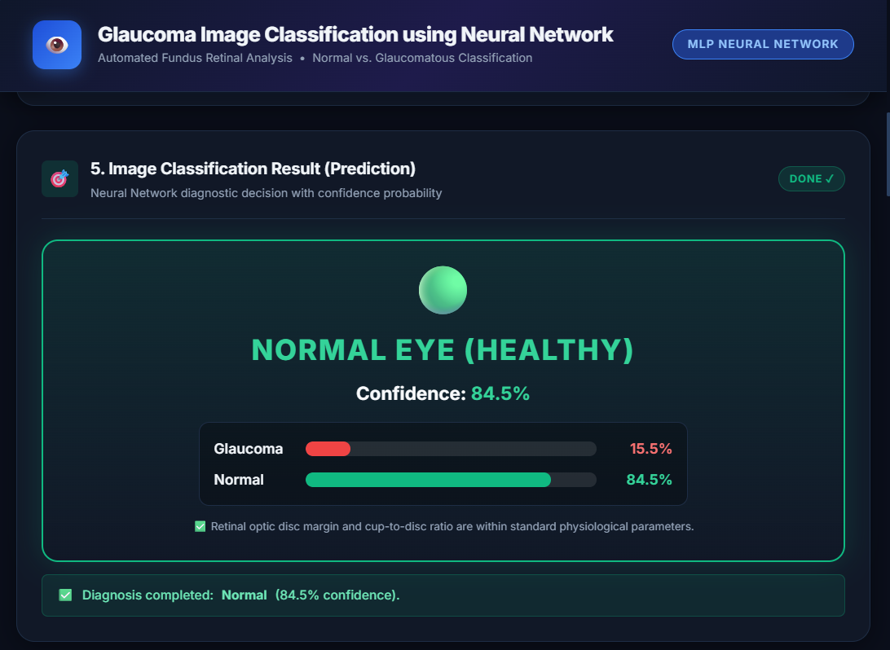
Fig 9: Step 5 — Classification result: Normal Eye (Healthy), 84.5% confidence

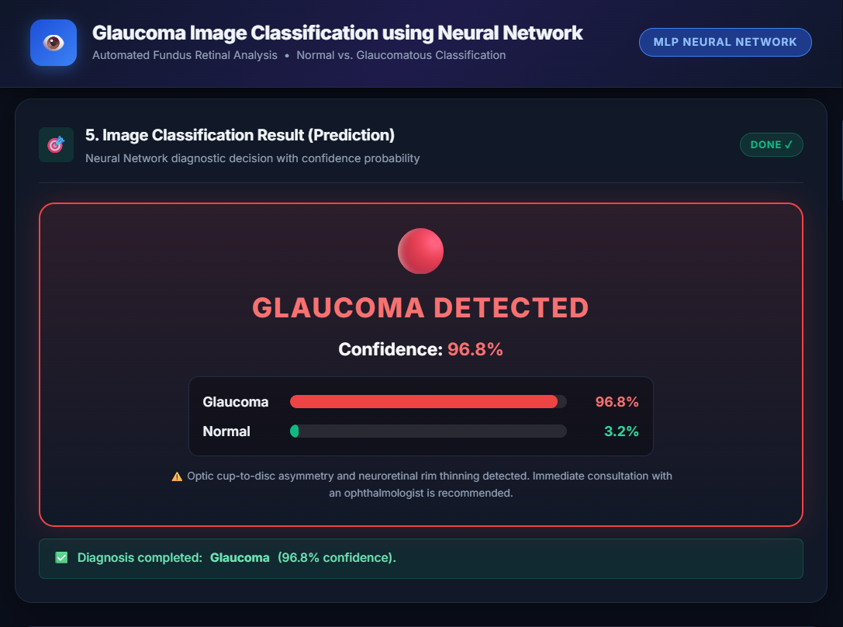
Fig 10: Step 5 — Classification result: Glaucoma Detected, 96.8% confidence
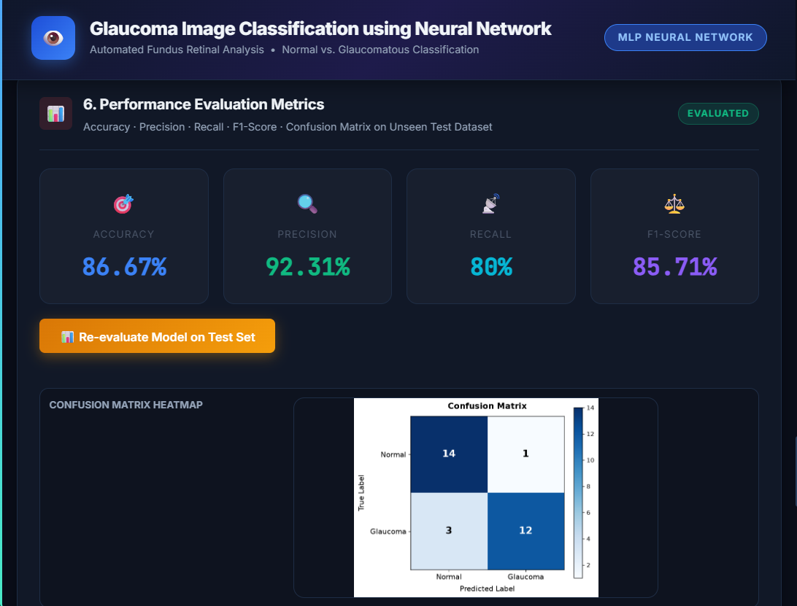
Fig 11: Step 6 — Performance evaluation metrics (Accuracy 86.67%, Precision 92.31%, Recall 80%, F1-Score 85.71%) and confusion matrix
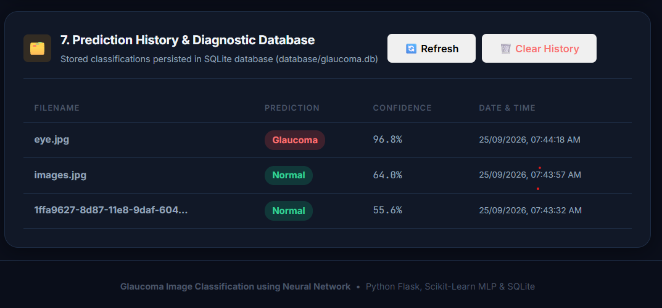
Fig 12: Step 7 — Prediction history log persisted in the SQLite diagnostic database
Result:
A web-based Glaucoma Image Classification system was successfully designed and implemented using a Flask backend, an MLP neural network classifier (scikit-learn), and an SQLite database. Fundus images are preprocessed, a 128-dimensional feature vector is extracted, and the trained MLP model classifies the image as Normal or Glaucoma with a confidence score. On the held-out test set, the model achieved an Accuracy of 86.67%, Precision of 92.31%, Recall of 80%, and an F1-Score of 85.71%, and every prediction is logged to a diagnostic history database.

